

The Peples Republic of Bangladesh
Minstry of Health &Family Welfare (Health Services Division)
Health Economic Unit (HEU). Shasthyo Surokhsha Karmasuchi (SSK) Topkhana Road, Dhaka-1000

Replication of Chowgacha UHC-Jhenaidah District Hospital Model in Tangail District.

Visit Report: Chowgacha Upazilla Health Complex, Jashore.
Date of Visit: 05/05/22.AT 9-30AM.
Visitor: Dr.Md. Emdadul Haque, National Consultant (HEU) of MoHFW.

Admistrative discussion: Discussion with Dr. Lutfun Nahar, UH&FPO, RMO and other MOs about activites of the Model UHC, Chowgacha and its latest situation. The hospital is 50 bedded. The hospital stood 1st and awarded by ”Health Minster’s Award” for its best performance among all the Upazilla Health Complex of the country on 07-04 22.Therer are many positive sides in this hospital and a few weak points described below.

2.Regarding attendance, accoding to the analysis of thumb impression for the month of March 2022, it was obserbed that with few exceptions most of the Consultants and MOs did not come and checked out in time.
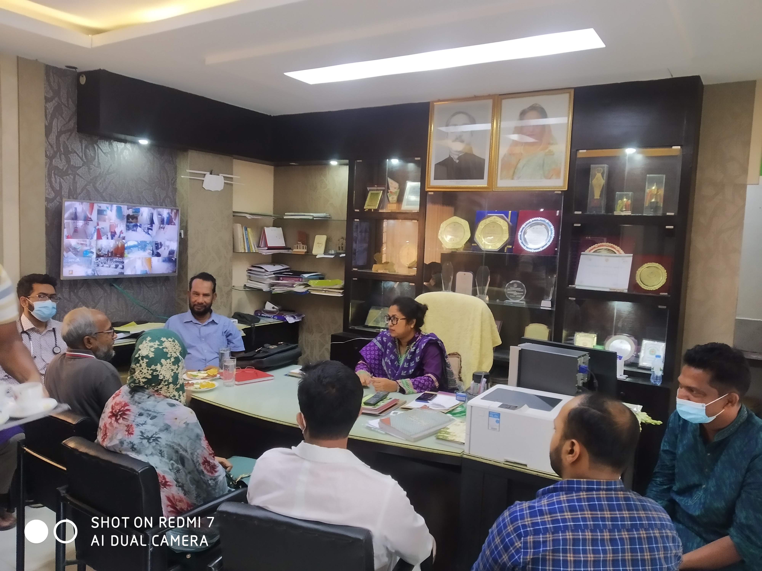
Meeting with UHFPO, RMO and Medical Officers at Chowgacha UHC on 5 May 2022

3.Important Human Resource gap:
Sl No | Post | Allocated Post | Filled-up post | Vacant post | Comment
1 | RMO | 1 | 1 | 0 | In-charge
2 | Consultants | 10 | 3 (Anesth, Ortho, Gynae) | 7
3 | MO/Asst Surgeon (UHC + UnionH&FWC). | 20 (9+11) | 13 (5+8) | 7 (4+3)
4 | SACMO (Health Complex + Union (H & FWC) | 15 (2+13) | 11 | 4
5 | Head Asst, Accountant,  Casher | 3 | 0 | 3
6 | HI+AHI+HA | 43(2+6+35) | (0+0+21) | 21
7 | MLSS (UHC + U H&FWC) | 8 (4+4) | 2 (1+1) | 6 (3+3)
8 | Word Boy+Aya | 5 | 2 | 3
9 | Cleaner | 5 | 2 | 3
10 | MT(Lab) | 3 | 1 | 2
11 | Community supported manpower |  | 26
 | Total Human Resource | 209 | 137 | 72

3.The performance of EOC service is musch better compare to many district hospitals of the country. But there is one gynoechologist in current charge and one anesthesiologist is working there. So, 24/7 EOC service is not going on.
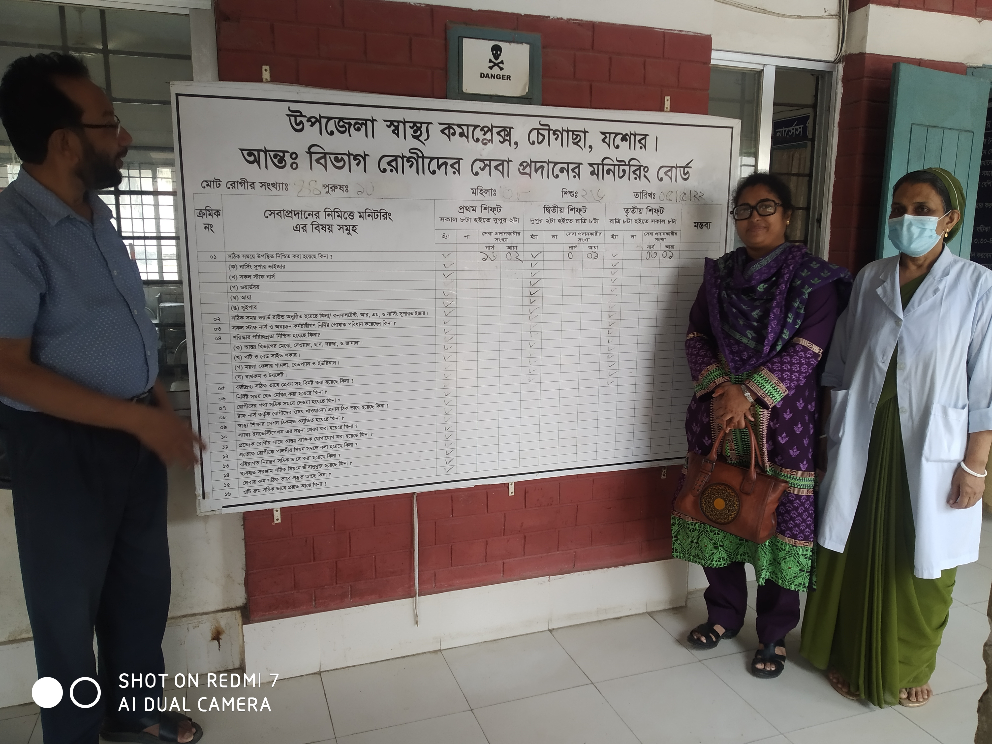
Monitoring system of the activites of nurses in indoor of Chowga UHC, UH&FPO Dr. Lutfun Nahar and Nursing Super Mrs.Jhumur Howlader were present on 05- 05-22.

2.Visit to the emergency, out door & indoor: We visited the hospital campus with UH&FPO and RMO
- Campus is clean & beautiful. Cycle stand is close to the main gate.
- Writtings of many billboards are unclean, which hampers butification.
- Emergency managemet system is effective. Sterility is not maintaning properly.
- Lab service is not organized and not running effectively.
- Outdoor service is organized. Health education system is weak.
- Indoor: Effective labour word, A Cangaro care Corner is there. Information display system is weak. No Shoe-free enviornment in labour word. 24/7 EOC OT service is not available. EOC OT is not clean.
- Death recording system is weak, need special attention.

3.Conclutions: Maintenance of office time is essential. Fulfilment of vital posts is important for sustainability and further development of Chowgacha Model.One Gynaecologist (On deputation), one anestheologist, (0n deputation), one MT(Lab), head assistant, accountant, 3 cleaner, 2 HI , 6 AHI, 14 HA is very essential. It is important to provided orientation on 7th Fiveyear plan, the components Chowgacha Modeland 5S- KAIZEN TQM for new officers and staffs.

Action plan to solve the problames.
Sl No | Components | Responsibilities |  | Duration
1 | Infection prevention in emergengcy | EMO/RMO |  | 5 Day
2 | Health education in o | QIC and WIT team |  | 10 Day
3 | Identification of Problems | QIC and WIT team |  | 10 Day
4 | Determining the vision, goals and goals | QIC team |  | 15 Day
5 | Motivation through the workshop to achieve the commitment of the people and the service providers to implement the goals | Local Hospital/ Upazilla Health Complex Authority |  | 30 Day
6 | Preparation and collection of necessary materials | Local Hospital/ Upazilla Health Complex Authority |  | 80 Day
7 | Prepare policies for building value-based work-environment a institutional culture | QIC Team |  | 15 Day
8 | Communication with all stakeholders to develop social movements to achieve the goal | Community Support Group and Local Health Authority | 10 Day
9 | Training on quality development 5S KAIZEN-TQM. | Local Health Authority | 7 Day
10- | Achieve practical knowledge through a team visiting the Chowgacha UHC and Jhenaidah Sadar Hospital | National Technical Committee | 3 days

Problmes of all the Upazilla UHC
1.Goal & objectives is not clear to the service provider.
2.Regular attendance of the officers and staffs are not ensured.
3.Post of many vital staffs are vacant.
4.5SKAIZEN-TQM program is not running on.
5.With the Exceptio of 2 UHC all other UHC by ranking according HSSS score not within100.
6.Consept of SSK program is not clear to the service provider.
6.Weakness in maintaining good relation with the community leaders, local administration & other officers
7.Community participation is neglesable.
8.IPD service of Sadar upazilla & Tangail district sadar Municipality should be hamper as there is no OPD& IPD service in Sadar UHC .
9.100 bedded UHC building is complited but having no administrative order in Modhupur.

Important support from HEU.
1.Most vulnerable population (BLP) is getting the support.
2.Reconstruction of Infrastructure & service oriented arrangement has done.
3.Lab service is improved.
4. 4th class employ support is very helpful for the service delivery system.
5.Over all capacity of the hospital has been inceeased.

Few questions arise from their phylosopis?

1.What is the main duty of a govt. doctor?
2.Is he/ she a development worker?
3.What is the importance of morality in health service management?
4.Role of SSK in development among the target group?
5.What are the importance of maintaining the relation with local administration, officers & community leaders.
6.How they can asses their improvement by indicators.
7.How they can maintain the secutity of the hospital?
8.How they can get community participation?

Recommendatios.
1.The phylosophies of the health sevice should clear.
2.Moralbased healthenvernment (Low cost,effective & based on morality) should be develop.
3.Leadership development is essential.
4.Goal &targets should be clear.
5.Information based responsibility must be devlvelop.
6.5S KAIZEN-TQM should be develop.
7.Community participation is essential.
8.Good relation with local administration & Police administration.
9.Follow the service system of Chowgacha model.
10. Good relation with high officials

